

**UNIVERSITI TEKNOLOGI MARA**

**CAWANGAN MELAKA, KAMPUS JASIN**

**ITT 450**

**GROUP: M3 CS251 4B**

**JERSEY ORDERING SYSTEM**

**LECTURER: SIR MOHD ALI MOHD ISA**

|  |  |
| --- | --- |
| **STUDENT ID** | **NAME** |
| 2017134697 | AKMAL BIN ABDUL HALIM |
| 2017733941 | AHMAD IBRAHIM FITRI BIN MD ISMA |
| 2017174373 | LIYANA BATRISYIA BINTI AHMAD AZIZI |
| 2017578455 | NURSYAZA IRDINA BINTI ABDULLAH MAHFUD |

**SCENARIO 1: ADMIN VIEWS, EDITS AND DELETES CREDENTIALS FROM THE SYSTEM**

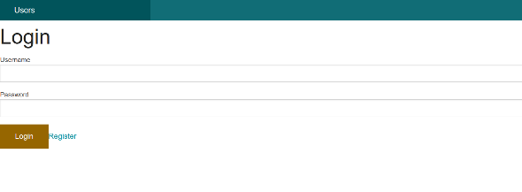

Admin will login in order to check or edit data in the system. Details such as username and password are needed.

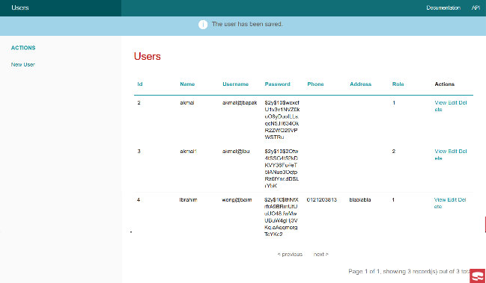

Once authorized, admin will be directed to a page containing a list of system’s admins.

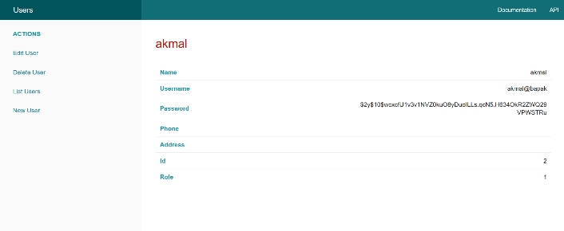

Admin can wish to view any admins’ data on the list.

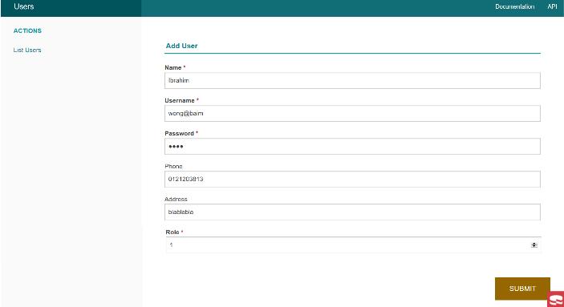

Admin can add new user to the system.

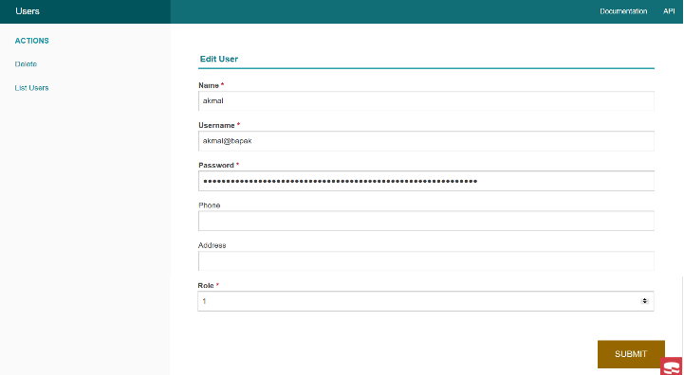

Admin can edit their own credentials on edit users’ page.

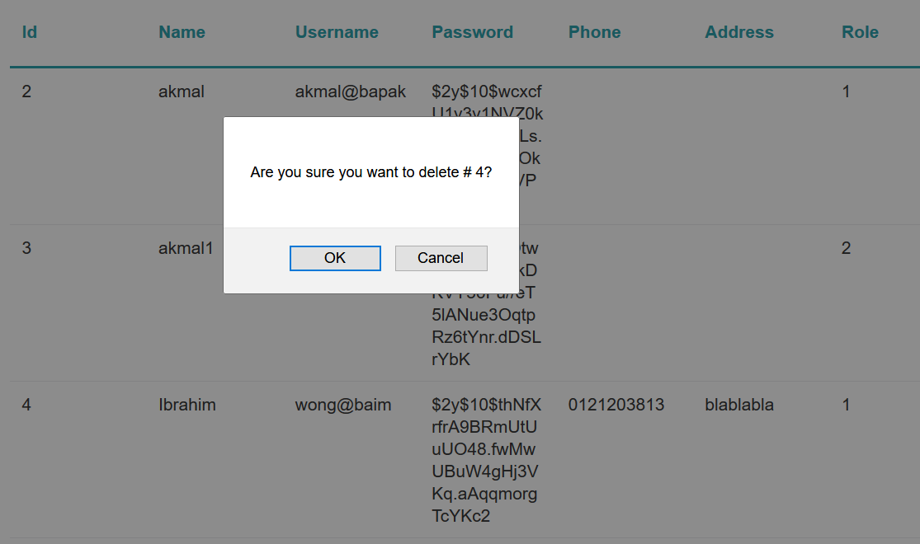

If admin wishes to delete data of a user, they just have to click on “delete” button.

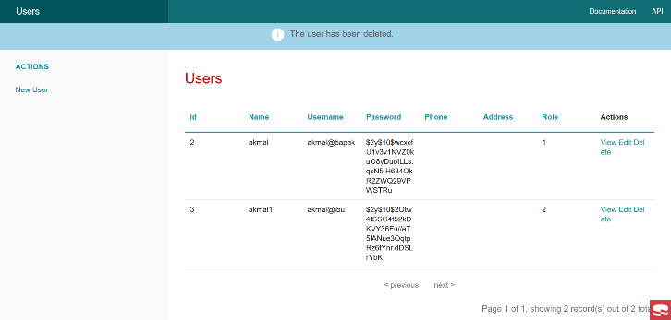

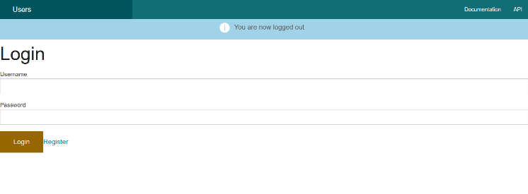

The logout page once everything is done.

**SCENARIO 2: CUSTOMERS WANTED TO MAKE ORDERS FROM THE SYSTEM**

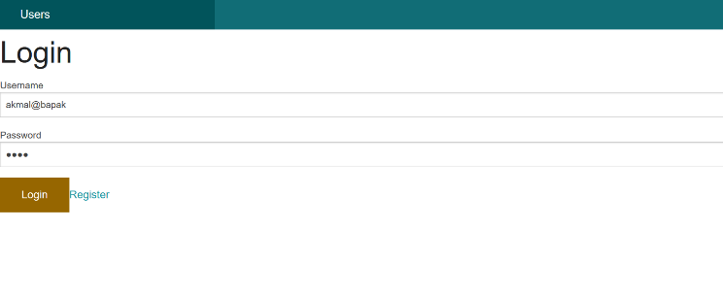

Customers will login to place their order.

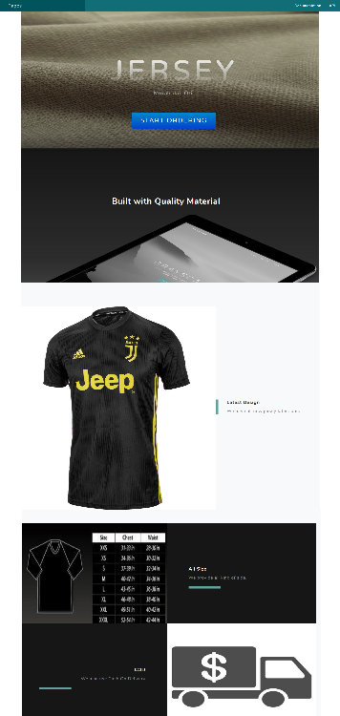

This is the homepage that customers will see once they are logged in. Customers will then click on the “START ORDERING” button to place their order.

The following page is the “List Page” where customers get to choose what they wanted to order.

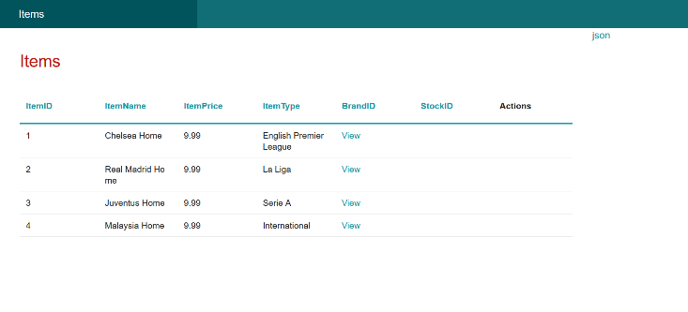

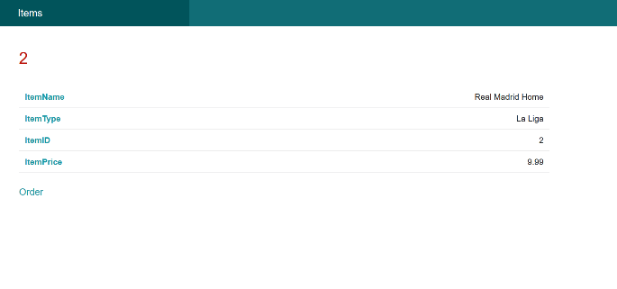

Customers get to see what they ordered by clicking the “Order” button. Customers will then be redirected back to the homepage.

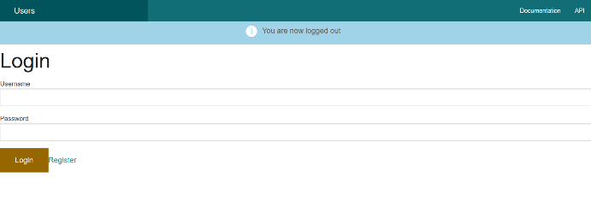

Customers can then log out from the system.

**SCENARIO 3: ADMIN CAN EDIT DATA FROM ORDERING LIST ON THE SYSTEM**

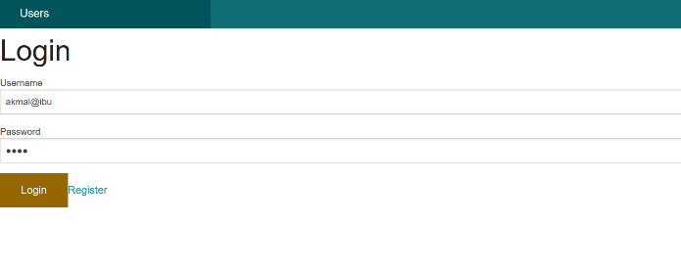

Admin will login in order to check or edit data in the system. Details such as username and password are needed.

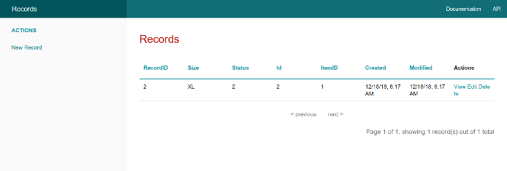

Admin has the rights to see all the ordering records from the customers.

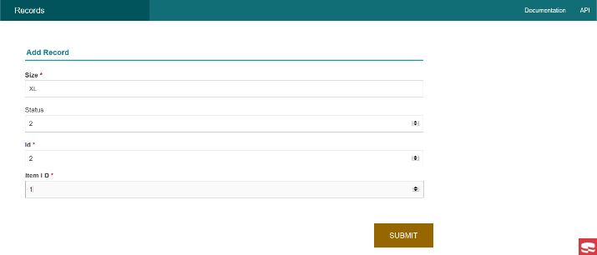

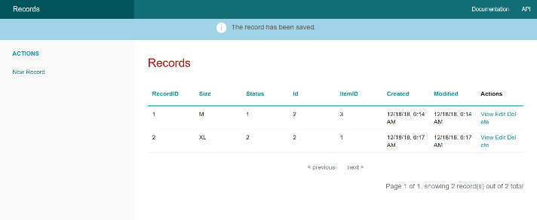

Admin can add new order to the system.

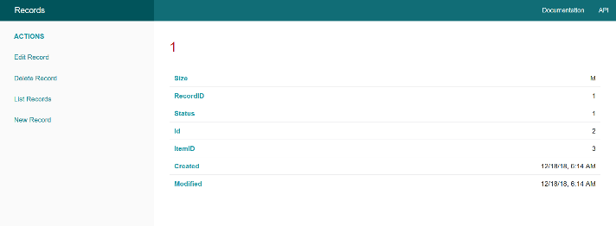

Admin can view one of the data and edit it.

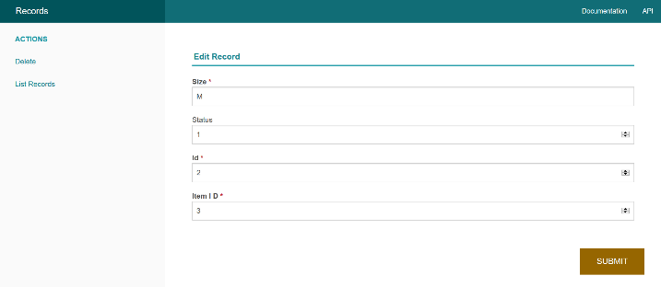

Admin can add records if they wish to. Once submitted, admin will be redirected back to the previous page with new data added.

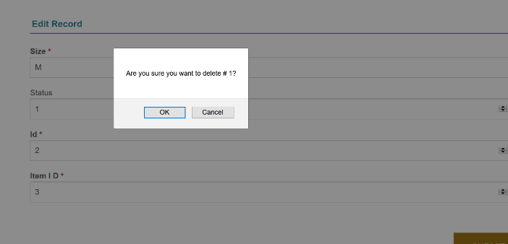

Admin wishes to delete a record.

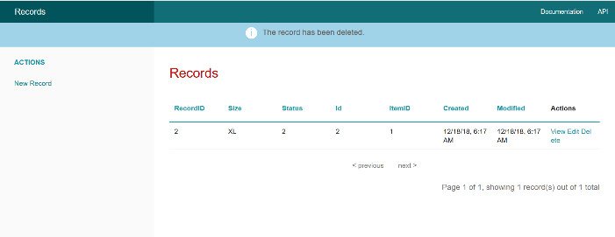

This is the page that appears when admin deleted one of the records available.

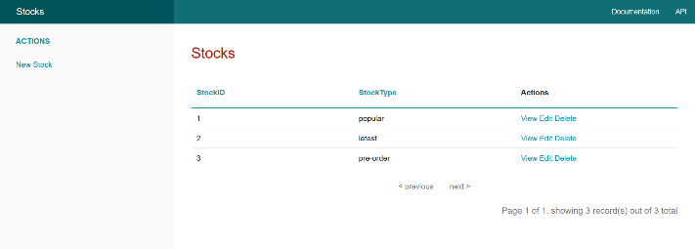

Admin has the rights to see all the ordering records from the customers.

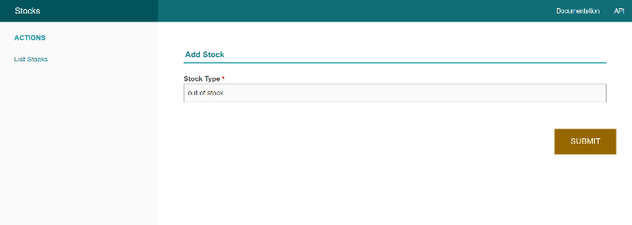

Admin can add stocks if they wish to. Once submitted, admin will be redirected back to the previous page with new data added.

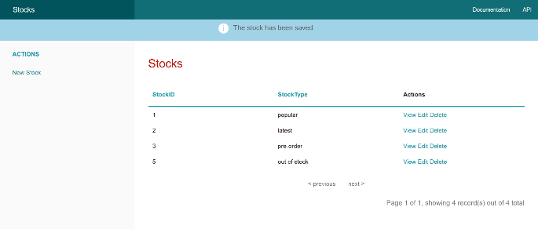

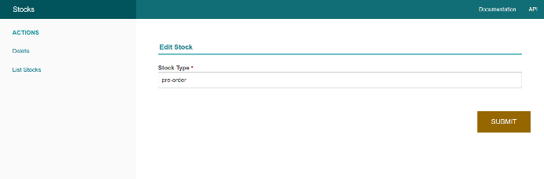

Admin has the rights to edit stocks if they want to.

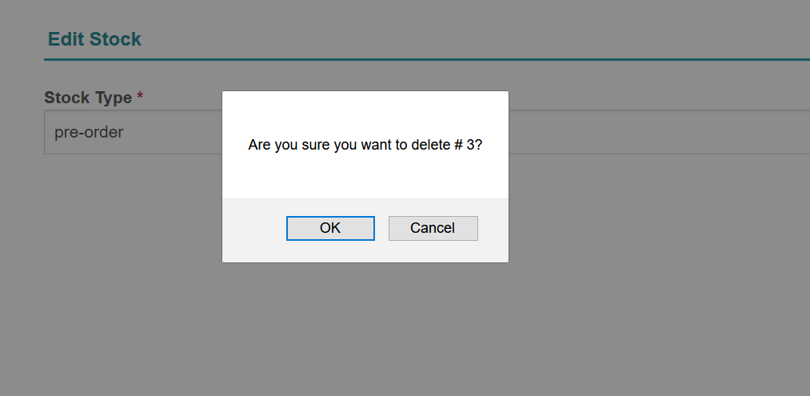

Admin wishes to delete a record.

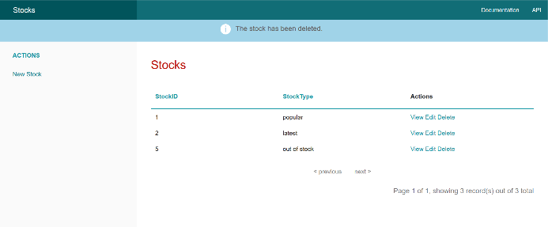

This is the page that appears when admin deleted one of the records available.

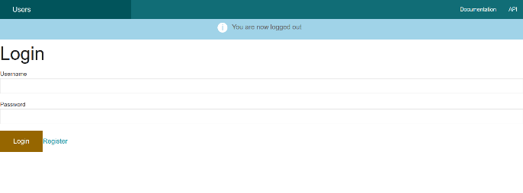

The logout page once everything is done.